How do we assess reading?
A combination of high quality assessment programs which combine to provide a whole picture of a child’s reading progress and attainment.
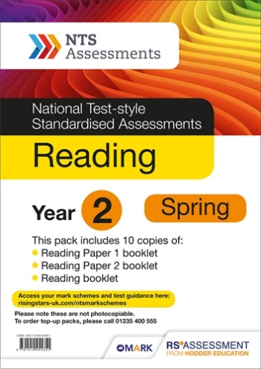 | We use NTS reading tests to measure and track the progress and attainment of our pupils from Y1-Y6.
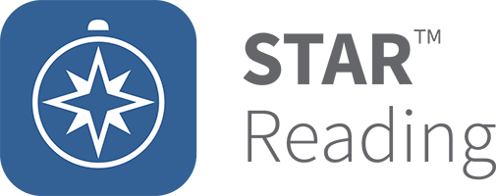 | Accelerated reader’s Star Reader testing provides us with in-depth analysis of our pupils reading skills and abilities including a reading age and gap analysis tool. We send these reports home to parents half termly to keep them informed of their child’s progress.
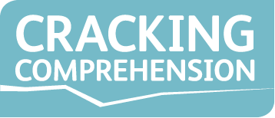 | We use Cracking Comprehension in years 2-6. After each teaching text there is an assessment task which we can use to address gaps and next steps.
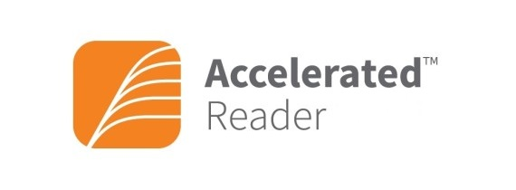 | Children quiz weekly on the books they are reading daily. Each quiz has a points score and an accuracy percentage which enables children to progress to meeting their target. They provide snapshots of pupil comprehension skills and allows us to track the accuracy of pupils reading.
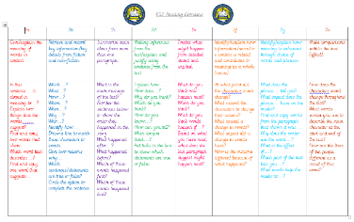 | 1:1 reading time with an adult is another chance for teachers to assess pupils against the reading content domains. It allows us to focus on certain domains which pupils may find tricky and ensure children are consistently challenged with their reading.
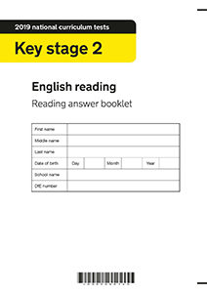 | In Y6, SATS tests are used from previous years to provide a picture of ability and progress. They also provide information on gaps and next steps.
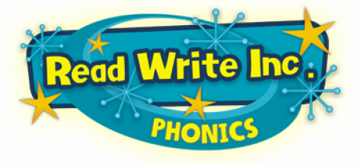 | RWI phonic assessments are used to track groupings and pupil progress. Tests are carried out frequently to ensure all children are making good progress and are in the appropriate group. This ensures pupils are being challenged and lower attaining pupils are receiving the support they may need.
 | Pre-school and F2 use Target Tracker to assess their children against the EYFS framework. Observations are recorded.

