The Priory Parish CE Primary School

Writing Policy 2020
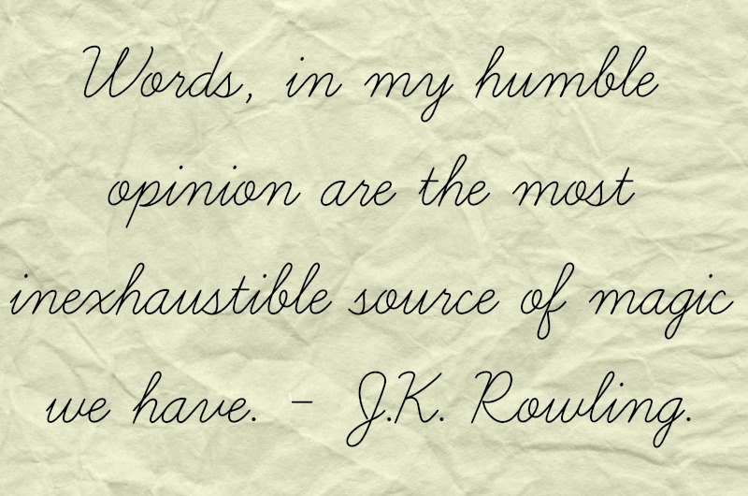

‘As a Christian family, together, we will realise our God- given ability to change the world.’

Our Goal and Aspiration
To ensure every child leaves our school as a competent, confident writer, knowing that the things they write can have the power to change their own lives and the lives of others.

Aims
- That every child leaves our school as a confident, able writer.
- That our children understand that writing is a powerful tool which can be used to change the world for the better.
- That our children can use, know and understand a vast array of vocabulary to support their future education.
- That our pupils feel confident in their writing ability and possess all of the writing skills they need to succeed in their futures.

Language
We understand and recognise the crucial importance in teaching our pupils at The Priory Parish a rich and varied vocabulary throughout their time here. Our pupils are in need of this to develop their overall understanding of the world around them.
Through the use of modelling a rich and diverse vocabulary, and exposing our children to high quality texts in which they encounter many new words, we strive to ensure our pupils develop their language skills on a daily basis. This is also supported by our ‘Adventurous Vocabulary Policy’. Our aim is that our pupils can use this language acquisition in their own writing.
The Teaching of Writing
We have adopted the approach ‘Read to Write’, which uses inspirational and engaging texts to teach the skills of both reading and writing. This approach immerses the pupils in high quality literature, developing their vocabulary, grammar, refining the skills of the whole writing process and developing editing skills.
We also use ‘Babcock Spelling’ to consolidate spelling skills in years 2-6 and also ‘Babcock Grammar’ to ensure competence and consolidation of grammar skills. This is taught in years 2-6.
See our separate handwriting policy which shows how we teach cursive form throughout the whole school.
Foundation Stage
Foundation Stage use RWI Phonics to teach the early skills of letter formation, writing words/sentences and spelling. They are immersed in exciting experiences, backed up by quality literature and continuous provision.

Y1
Y1 use a combination of both RWI to teach the important skills of phonics and spelling and also follow the Read to Write approach to ensure immersion in quality language. This also teaches the crucial skills of the whole writing process.
Skilled Adults
At The Priory Parish, much time has been invested into the training of teaching staff and support staff so that they are equipped and confident to deliver and support the teaching of writing. Teachers and Teaching Assistants have been trained in how to deliver Read to Write lessons, RWI, spelling, grammar and handwriting. CPD is ongoing to ensure staff are always kept fresh and up to date in any developments, strategies or ideas to support the writing process.
Phonics and spelling to support writing
At The Priory Parish, children in Pre-School begin daily phonics lessons during Summer term. F2 to Y1 have whole class daily phonics teaching all year. Y2 are supported by intervention groups and the daily teaching and revision of sounds and spelling patterns.
In years 2-6 Babcock Spelling is used to support, practise and consolidate the spelling strategies which are already covered in Read to Write.
Children who need additional support receive extra lessons in the form of intervention groups.

Presentation
The Priory Parish has high expectations of presentation in all of our pupils. We know this is a crucial aspect in our children taking pride and care in their work. All children begin school learning the pre- cursive form straight away which ensures the smooth progression into continuous cursive as soon as they are ready. Children are encouraged and expected ‘to always do their very best work’ and beautifully presented work is celebrated and praised by all staff.
Assessment of writing
Assessment for writing is ongoing. We assess using the Read to Write assessment documents and the statutory teacher assessment frameworks in Y2 and Y6.
We make a judgement in Autumn, Spring and Summer to track and monitor progress, support and attainment.
Both in house and cluster moderation is used to ensure our judgements are both accurate and consistent.
We use a variety of sources to make our judgements including: independent writing books, English books, handwriting books, cross-curricular writing, phonics work, spelling tests and books and grammar activities.
Foundation Stage assess writing using Target Tracker.
Big Write
The whole school from F2-Y6 completes an independent ‘big’ piece of writing once a fortnight. The work during the week builds up to this piece, teaching the vocabulary, features, grammar and sentence structures which will support this final piece of work. The actual write is modelled during the week and then children write independently, applying all of their skills. This piece of writing is marked ‘in-depth’ providing two stars and a ‘next step’ target. Children respond to this feedback using ‘purple pen time’. Younger children receive feedback verbally to ensure they understand what they have achieved and what their next step is. Independent writing books form a a large part of our writing assessment process as the work within them shows independent application of what the children know.
Cross- Curricular Writing
Cross-curricular writing is an important part of the writing process in allowing children to apply their skills to a range of purposes and experiences. Our expectations are the same for cross-curricular writing as with any English session. When assessing writing, cross-curricular writing is used to support making a judgement. All children are expected to apply their writing skills in a cross-curricular way and this is frequently monitored.
Equal Opportunities
We will ensure that all children have equal access to the curriculum, regardless of gender, race, religion or ability. Children with specific writing, speech and language or hearing difficulties will be identified and supported through support programmes in school and external help will be sought where necessary.
SEN
Pupils with difficulties in learning to write or with Special Educational Needs have their needs identified promptly and interventions provided that will accelerate their progress. Progress is measured and tracked to ensure they are catching up with their peers. In KS1 for example, additional teaching and support is provided through 1:1 phonics and spelling work with an adult, extra writing practise, focusing on sentence structure and punctuation in small groups.
In KS2 additional teaching is provided through writing and spelling support groups with an adult.
Below ARE
Children who are below ARE will receive intervention and support in a small group.
GDS
Read to Write is pitched at GDS standard which ensures consistent immersion of complex and interesting vocabulary. GDS pupils are challenged and stretched in aspects such as spelling, grammar, sentence structure and language. This may be done through coaching, feedback or group support.
EAL
EAL “Catch up” Phonics sessions are provided straight away for new EAL arrivals and with the support of MEAS team, we assess their reading/ basic writing skills promptly. We provide dual language resources to help build understanding and ensure the children feel comfortable.
Working Walls to support writing
Our working walls are a crucial aspect of the writing process. Throughout a ‘unit’ materials are collected and put on the wall which becomes a vital tool in collecting and consolidating the knowledge needed to complete a successful piece of writing. Aspects such as: vocabulary, sentence structure, grammar tips, spellings, ideas, images, targets, checklists are all included. Children actively contribute to, and use the wall independently. They are successful in showcasing the whole writing process from start to finish- including support for the editing process. Staff have received training on creating successful working walls and they are monitored frequently by SLT.
Leadership and Monitoring
Monitoring of the teaching and learning of writing takes place through various means:
- Observations of English lessons including ‘big write’ sessions, intervention groups, grammar and spelling sessions and phonics teaching.
- Monitoring of planning, work and record keeping.
- Monitoring of working walls.
- Learning walks to establish whether writing has been given a high profile within each classroom (displays, support work on display including grammar and spelling tips.
- Full book scrutiny including big write books, English books and topic work.
Evidence gathered is used to form training requirements, support needs and resourcing. Clear feedback is always shared with the staff to ensure progression in the teaching of writing and to share good practice.
Policy Review
This policy will be reviewed termly and is a working document.
