The Priory Parish CE Primary School
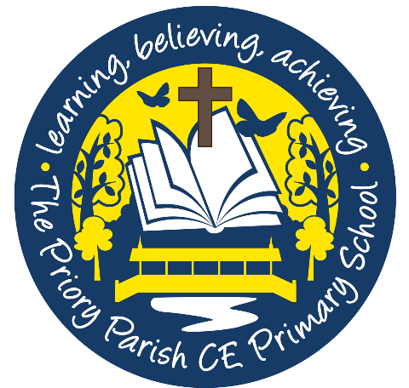

Book Spine
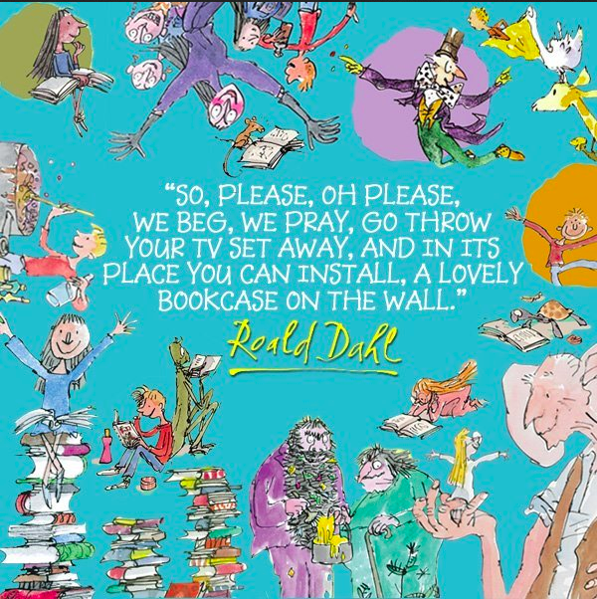

This document is a suggested reading list for the school. It has been collated, with staff and research based recommendations, to deliberately expose the children to inspirational authors, a range of genres and key texts that we would want them to have encountered by the time they leave primary education.

We want this spine to promote and instil a love of reading in all of our pupils and have ensured the range is vast, inspirational, challenging and enjoyable.

Certain books have been included to fit with the appropriate Literacy Counts units for each year group. Reading with each class, whether in the English lesson or at class novel time/ snack time should occur daily. Nothing is more important than sharing and enjoying stories with our children.
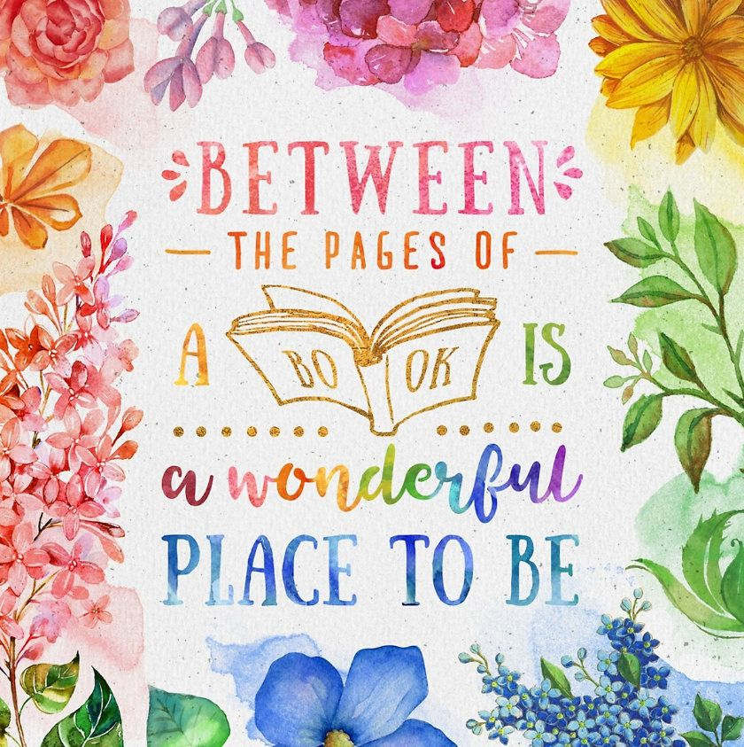

Our book spine should always remain a working document - excellent new books are always been written and discovered and so may change year on year.

To be reviewed July 2021.

Research
The 5 Plagues of the Developing Reader (source: Reading Reconsidered by Doug Lemov) There are five types of texts that children should have access to in order to successfully navigate reading with confidence.
Archaic Language | The vocabulary, usage, syntax and context for cultural reference of texts over 50 or 100 years old are vastly different and typically more complex than texts written today. Students need to be exposed to and develop proficiency with antiquated forms of expression to be able to hope to read James Madison, Frederick Douglass and Edmund Spenser when they move on to secondary school and beyond.
Non-linear time sequences | In passages written exclusively for students-or more specifically for student assessments— time tends to unfold with consistency. A story is narrated in a given style with a given cadence and that cadence endures and remains consistent, but in the best books, books where every aspect of the narration is nuanced to create an exact image, time moves in fits and starts. It doubles back. The only way to master such books is to have read them time and again and to be carefully introduced to them by a teacher or adult.
Narratively complex | Books are sometimes narrated by an unreliable narrator. Scout, for example, who doesn’t understand and misperceives some of what happened to her. Or the narrator in Edgar Allan Poe’s “The Tell-Tale Heart” who is a madman out of touch with reality. Other books have multiple narrators such as Faulkner’s As I Lay Dying. Others have non-human narrators such as the horse that tells the story in Black Beauty. Some books have multiple intertwined and apparently (for a time) unrelated plot lines. These are far harder to read than books with a single plot line and students need to experience these as well.
Figurative/Symbolic text | Texts which happen on an allegorical or symbolic level. Not reflected in Lexiles; critical forms of text complexity that students must experience.
Resistant texts | Texts written to deliberately resist easy meaning-making by readers. Perhaps half of the poems ever written fall into this category. You have to assemble meaning around nuances, hints, uncertainties and clues.

Pre-School

The Gruffalo- Julia Donaldson
Kind- Alison Green
We’re going on a bear hunt- Michael Rosen
The Very Hungry Caterpillar- Eric Carle
Each Peach Pear Plum- Allan and Janet Ahlberg
Brown Bear, Brown Bear, What Do You See?- Bill Martin Jnr and Eric Carle
Dear Zoo- Rod Campbell
Sharing a Shell- Julia Donaldson
The Tiger who came to Tea- Judith Kerr
Avocado Baby- John Burningham
Guess how much I love you- Sam McBratney
That’s not my... collection- Fiona Watt
What the Ladybird Heard- Julia Donaldson
Traditional Tales: Jack and the beanstalk, Three little pigs, Three Billy Goats Gruff, Goldilocks and the three bears.
A Little Bit Brave-Nicola Kinnear
A Treasury of songs- Julia Donaldson

Plus a rich diet of nursery rhymes and rhyming stories.

F2

Meerkat Mail-Emily Gravett
Be Gentle- Virginia Miller
Funnybones- Janet and Allan Ahlberg
Dear Greenpeace- Simon James
Peace at last- Jill Murphy
Superworm- Julia Donaldson
Supertato- Sue Hendra and Paul Linnet
Rainbow Fish-Marcus Pfister
The star that fell- Karen Hayles
How to catch a star- Oliver Jeffers
Lost and Found- Oliver Jeffers
The Boy who Unplugged the Sea-Paul Brown
Tiddler- Julia Donaldson
The Enormous Turnip-Irene Yates
Nobot Robot- Sue Hendra and Paul Linnet
Handa’s Surprise- Eileen Browne
The Something- Rebecca Cobb
Little Red-Bethan Woolvin
Juniper Jupiter-Lizzy Stewart
The Storm Whale- Benji Davies
The Extraordinary Gardener-Sam Boughton
Mr Grumpy’s Outing- John Burningham

Y1

Hermelin-Mini Grey
Where the Wild Things are- Maurice Sendak
Rapunzel- Bethan Woolvin
The secret of Black Rock-Joe Todd Stanton
Dogger -Shirley Hughes
Elmer - David McKee
Lost and Found - Oliver Jeffers
Peter Rabbit- Beatrix Potter
Flat Stanley- Jeff Brown
A children’s treasury of Milligan- classic stories and poems by Spike Milligan
Owl Babies- Martin Waddell
Hansel and Gretel- Anthony Browne
Gorilla- Anthony Browne
The Snail and the Whale- Julia Donaldson
The Gingerbread man
Shark in the Park-Nick Sharratt
The Lighthouse Keeper’s Lunch- Ronda and David Armitage
Beegu- Alexis Deacon
Paper Planes-Jim Helmore
The Last Wolf- Mini Grey
There’s a Tiger in the Garden-Lizzy Stewart
Y2

Rosie Revere Engineer-Andrea Beaty
Grandad’s Island- Benji Davies
The Bog Baby-Jeanne Willis
Night Gardener-The Fan Brothers
When the rain comes-Malika Favre
The Flower- John Light
The Scarecrow’s wedding- Julia Donaldson
Can you catch a mermaid?- Jane Ray
The Tear Thief- Carol Ann Duffy
Traction Man is Here-Mini Grey
On Sudden Hill- Linda Sarah and Benji Davies
The Last Wolf- Mini Grey
George’s Marvellous Medicine- Roald Dahl
Jabberwocky- Lewis Carroll
Revolting Rhymes- Roald Dahl
Ocean meets sky- The Fan Brothers
The Day the Crayons Quit- Oliver Jeffers
Spells- Emily Gravett
The rhythm of the rain- Grahame Baker Smith
Jack and the Baked Beanstalk- Colin Stimpson
Leon and the Place Between- Angela McAllister
A River- Marc Martin
The King who banned the dark-Emily Haworth-Booth

Y3

Seen and not heard- Katie May Green
Jemmy Button- Valerio Vidali
Into the Forest- Anthony Browne
Return- Aaron Becker
Fox- Margaret Wild and Ron Brooks
The Iron Man- Chris Mould and Ted Hughes
Stone Age Boy- Satoshi Kitamura
The Egyptian Cinderella- Shirley Climo
The Vanishing Rainforest- Richard Platt
Charlie and the Chocolate Factory- Roald Dahl
The Wolves in the Walls- Neil Gaiman
Starbird- Sharon King Chai

Ted Hughes- Collected Poems for Children

Y4

The Whale- Vita Murrow
The Journey- Francesca Senna
Leaf- Sandra Dieckmann
Manfish- Jennifer Berne
Arthur and the Golden Rope- Joe Todd- Stanton
Lost Happy Endings- Carol Ann Duffy
Wisp- A story of hope
Escape from Pompeii- Christina Balit
Aesop’s Fables- Don Daily
Greek Myths- Marcia Williams
Whale Boy- Nicola Davies
Why the Whales came- Michael Morpurgo
Stories for boys who dare to be different- Ben Brooks
Goodnight stories for rebel girls-Elena Favilli and Francesca Cavallo

Carol Ann Duffy-New and Collected Poems for Children

Y5

Henry’s Freedom Box- Ellen Levine and Kadir Nelson
The Errand- Leo LaFleur and Adam Oehlers
King Kong- Anthony Browne
The Promise- Nicola Davies
Farther- Graham Baker Smith
The Lost Book of Adventure- Unknown adventurer
The Highway Man- Alfred Noyes
Running Wild- Michael Morpurgo
Journey to the River Sea- Eva Ibbotson
Kensuke’s Kingdom- Michael Morpurgo
A Monster Calls- Patrick Ness
The Island- Armin Greder
Our castle by the sea- Lucy Strange
Where once we stood- Christopher Riley and Martin Impey

Y6

Hansel and Gretel- Neil Gaiman
A story like the wind- Gill Lewis
Shackleton’s Journey- William Grill
Dreams of Freedom- Amnesty International
Rose Blanche- Roberto Innocenti and Ian McEwan
The Ways of the Wolf- Smith Prasadam- Halls and Jonathan Woodward
Wonder- R.J. Palacio
Holes- Louis Sachar
In Flander’s Fields- John McCrae
The Eagle- Alfred Lord Tennyson
The Arrival- Shaun Tan
Skellig- David Almond
Northern Lights- Philip Pullman
The Biy who sailed the ocean in an arm chair- Lara Williamson
The Hobbit- JRR Tolkien
On the Origin of Species- Sabina Radeva

