The Priory Parish CE Primary School
Relationships and Sex Education Policy
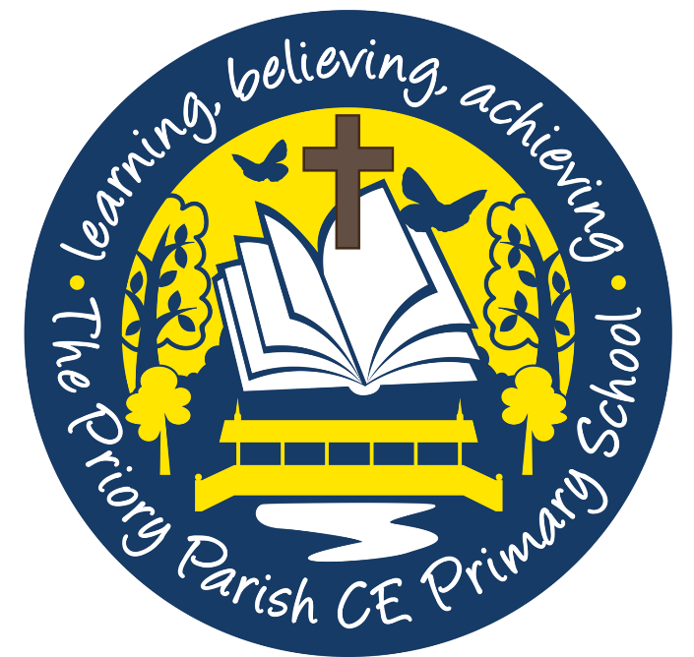
2021

Our Vision

“As a Christian family, together, we will realise our God- given ability to change the world.”

Foreword

Our school’s policy relationships and sex education (RSE) is based on guidance from the DFE’s Relationships and sex education 2019 document. It has been developed and refined through consultation with staff, governors and parents.
At The Priory CE Primary School, RSE is defined as learning about physical, moral and emotional development, love and care towards others and about the teaching of sex. Through the teaching of relationships and sex education, children will learn about attitudes and values, personal and social skills and will develop their knowledge and understanding. This will all be underpinned by our whole school vision and Christian values of: responsibility, friendship, love, kindness, faith and respect which we hold dearly.
Children are also taught about personal space and privacy as we know and believe this is a crucial aspect of safeguarding.

At The Priory CE Primary School we will:
- Develop confident and effective communicators who value themselves and others.
- Encourage enquiring minds.
- Meet the needs of all pupils enabling them to reach their full potential
- Provide children with an education appropriate to the world beyond the classroom
- Help children to live together within the community, displaying tolerance and sensitivity
- Develop in children a sense of moral responsibility and self-discipline
- Develop children’s spiritual awareness.
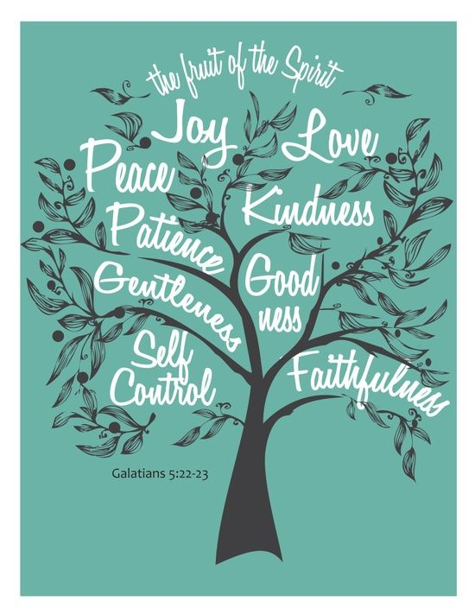
- Ensure our pupils know and understand the crucial foundations in creating healthy relationships with others.

Aims of our RSE Policy:
- To meet the requirements of the DfES guidance on RSE including the guidance on mental wellbeing.
- To help and support children through physical, emotional moral and spiritual development.
- To develop in children, the skills and understanding to have the confidence to approach their relationships in a positive way.
- To enable children to move with confidence from childhood through adolescence to adulthood.
- To live confident and healthy lives
- To understand the changes that occur to the human body during puberty
- To understand how a baby is conceived and born.
- To ensure children are aware of personal space and their right to privacy.

RSE in the curriculum
In each Year Group (F2-Y6) the children discuss key safeguarding issues linked personal space and privacy. The school utilises the NSPCC resources to promote children’s awareness of these issues in an age appropriate manner. The teachers sensitively ensure children are aware and understand the boundaries that should exist linked to the private areas of their body.
In Years F2- 4 children learn about:
- Developing the skills to have positive relationships with friends and family.
- An understanding of families/relationship set-ups.
- Exercise and personal hygiene.
In Year 5 and 6 children learn about:
- Developing the skills to be effective in relationships
- The different types of relationship, including marriage and those between friends and families. Children are made aware that different family set-ups exist (including homosexual relationships)
- How the body changes during puberty
- How a baby is conceived and born.
- Messages of sexuality developed in the media
At The Priory Parish CE Primary School, RSE is predominately taught through the resource ‘Heart Smart’ along with other aspects covered in RE and science. Everything we do and teach is always underpinned by our school vision and values which are close to our hearts. RSE curriculum is delivered in dedicated curriculum time. The programme is a graduated, age appropriate programme which will be delivered by the school staff with support and advice from health professionals including our school nurse at times.
In Y5 and Y6, both boys and girls receive the same input and understand the changes that occur in their own gender as well as that of the opposite sex. Teaching staff receive suitable training, when available, to ensure they are able to deliver sex and relationships lessons effectively. Guidance and input from the school nurse also supports this teaching. Resources used are made available for parents to view and a meeting with parents is arranged prior to the Year 5/6 lessons.

Sensitive Issues

From time to time, sensitive issues will be raised by pupils. Parents and others should be reassured that the personal beliefs and attitudes of a teacher should not influence the teaching of RSE. The issues concerned may include contraception, abortion, safe sex, HIV and other sexually transmitted diseases, sexual identity or orientation, homophobic bullying and different families. It is important to acknowledge that pupils may hear these terms through different sources such as the media, and need to feel able to ask for further information. The response from the member of staff will be appropriate to the child’s age and maturity, and thought will be given to whether the response is appropriate in a class, small group or individual situation. Lesson planning will clearly state the content that will be covered. Questions will always be treated with respect and with a caring response. Staff and other adults will always be sensitive to underlying problems which may be worrying a child.

The main guidelines in this situation are:

• Be sensitive;

• Is the context appropriate?

• Is the question relevant to the content of the lesson?

• Is the group ready in terms of maturity? In such instances, teachers may answer a question with the response “We are not learning about this in Year... You may ask your Mum/Dad /carer when you get home. You will learn more about this in Year.. (if known).” If staff have a concern, then parents may be contacted.
Questions raised by pupils are dealt with sensitively and any questions concerning sexually transmitted diseases and contraception are answered appropriately if raised. Inappropriate or explicit questions do not have to be answered directly. Teachers use their own discretion in these situations.
Homosexuality is discussed at a level appropriate to the age of the children. Children are reminded that ‘loving relationships’ can be between a man and a woman or people of the same sex. Teachers again use their own discretion in these situations when responding to children’s questioning. Children are taught to respect the life choices of others (including their sexuality). Homophobic bullying is discussed at a level appropriate the age of the children.
The portrayal of sex in the media is discussed at length in Y6 and the impact of social media on body image and mental health.
At Year 6 teachers may, where appropriate, split the group according to gender to discuss issues relating to puberty and sex; however this is not always the case.

Coverage

By the end of Primary school our pupils should know:

Families and people who care for me | - Pupils should know that families are important for children growing up because they can give love, security and stability.  - The characteristics of healthy family life, commitment to each other, including in times of difficulty, protection and care for children and other family members, the importance of spending time together and sharing each other’s lives.  - That others’ families, either in school or in the wider world, sometimes look different from their family, but that they should respect those differences and know that other children’s families are also characterised by love and care.  - That stable, caring relationships, which may be of different types, are at the heart of happy families, and are important for children’s security as they grow up.  - That marriage represents a formal and legally recognised commitment of two people to each other which is intended to be lifelong.  - How to recognise if family relationships are making them feel unhappy or unsafe, and how to seek help or advice from others if needed.
Caring friendships | - Pupils should know how important friendships are in making us feel happy and secure, and how people choose and make friends.  - The characteristics of friendships, including mutual respect, truthfulness, trustworthiness, loyalty, kindness, generosity, trust, sharing interests and experiences and support with problems and difficulties.  - That healthy friendships are positive and welcoming towards others, and do not make others feel lonely or excluded.  - That most friendships have ups and downs, and that these can often be worked through so that the friendship is repaired or even strengthened, and that resorting to violence is never right.  - How to recognise who to trust and who not to trust, how to judge when a friendship is making them feel unhappy or uncomfortable, managing conflict, how to manage these situations and how to seek help or advice from others, if needed.
Respectful relationships | - Pupils should know the importance of respecting others, even when they are very different from them (for example, physically, in character, personality or backgrounds), or make different choices or have different preferences or beliefs.  - Practical steps they can take in a range of different contexts to improve or support respectful relationships.  - The conventions of courtesy and manners.  - The importance of self-respect and how this links to their own happiness.  - That in school and in wider society they can expect to be treated with respect by others, and that in turn they should show due respect to others, including those in positions of authority.  - About different types of bullying (including cyberbullying), the impact of bullying, responsibilities of bystanders (primarily reporting bullying to an adult) and how to get help.  - What a stereotype is, and how stereotypes can be unfair, negative or destructive.  - The importance of permission-seeking and giving in relationships with friends, peers and adults.
Online Relationships | - Pupils should know that people sometimes behave differently online, including by pretending to be someone they are not.  - That the same principles apply to online relationships as to face-to face relationships, including the importance of respect for others online including when we are anonymous.  - The rules and principles for keeping safe online, how to recognise risks, harmful content and contact, and how to report them.  - How to critically consider their online friendships and sources of information including awareness of the risks associated with people they have never met.  - How information and data is shared and used online.
Being Safe | - Pupils should know what sorts of boundaries are appropriate in friendships with peers and others (including in a digital context).  - About the concept of privacy and the implications of it for both children and adults; including that it is not always right to keep secrets if they relate to being safe.  - That each person’s body belongs to them, and the differences between appropriate and inappropriate or unsafe physical, and other, contact.  - How to respond safely and appropriately to adults they may encounter (in all contexts, including online) whom they do not know.  - How to recognise and report feelings of being unsafe or feeling bad about any adult.  - How to ask for advice or help for themselves or others, and to keep trying until they are heard.  - How to report concerns or abuse, and the vocabulary and confidence needed to do so.  - Where to get advice e.g. family, school and/or other sources.

Mental Health and Wellbeing

We will also ensure coverage of mental health and wellbeing and by the end of primary school our pupils will know:

Mental wellbeing | - Pupils should know that mental wellbeing is a normal part of daily life, in the same way as physical health.  - That there is a normal range of emotions (e.g. happiness, sadness, anger, fear, surprise, nervousness) and scale of emotions that all humans experience in relation to different experiences and situations.  - How to recognise and talk about their emotions, including having a varied vocabulary of words to use when talking about their own and others’ feelings.  - How to judge whether what they are feeling and how they are behaving is appropriate and proportionate.  - The benefits of physical exercise, time outdoors, community participation, voluntary and service-based activity on mental wellbeing and happiness.  - Simple self-care techniques, including the importance of rest, time spent with friends and family and the benefits of hobbies and interests.  - Isolation and loneliness can affect children and that it is very important for children to discuss their feelings with an adult and seek support.  - That bullying (including cyberbullying) has a negative and often lasting impact on mental wellbeing.  - Where and how to seek support (including recognising the triggers for seeking support), including whom in school they should speak to if they are worried about their own or someone else’s mental wellbeing or ability to control their emotions (including issues arising online).  - It is common for people to experience mental ill health. For many people who do, the problems can be resolved if the right support is made available, especially if accessed early enough.
Internet safety and harms | - Pupils should know that for most people the internet is an integral part of life and has many benefits.  - About the benefits of rationing time spent online, the risks of excessive time spent on electronic devices and the impact of positive and negative content online on their own and others’ mental and physical wellbeing.  - How to consider the effect of their online actions on others and know how to recognise and display respectful behaviour online and the importance of keeping personal information private.  - Why social media, some computer games and online gaming, for example, are age restricted.  - That the internet can also be a negative place where online abuse, trolling, bullying and harassment can take place, which can have a negative impact on mental health.  - How to be a discerning consumer of information online including understanding that information, including that from search engines, is ranked, selected and targeted.  - Where and how to report concerns and get support with issues online.
Physical health and fitness | - Pupils should know the characteristics and mental and physical benefits of an active lifestyle.  - The importance of building regular exercise into daily and weekly routines and how to achieve this; for example walking or cycling to school, a daily active mile or other forms of regular, vigorous exercise.  - The risks associated with an inactive lifestyle (including obesity).  - How and when to seek support including which adults to speak to in school if they are worried about their health.
Healthy eating | - Pupils should know what constitutes a healthy diet (including understanding calories and other nutritional content).  - The principles of planning and preparing a range of healthy meals.  - The characteristics of a poor diet and risks associated with unhealthy eating (including, for example, obesity and tooth decay) and other behaviours (e.g. the impact of alcohol on diet or health)
Drugs, alcohol and tobacco | - Pupils should know the facts about legal and illegal harmful substances and associated risks, including smoking, alcohol use and drug-taking.
Health and prevention | - Pupils should know how to recognise early signs of physical illness, such as weight loss, or unexplained changes to the body.  - About safe and unsafe exposure to the sun, and how to reduce the risk of sun damage, including skin cancer.  - The importance of sufficient good quality sleep for good health and that a lack of sleep can affect weight, mood and ability to learn.  - About dental health and the benefits of good oral hygiene and dental flossing, including regular check-ups at the dentist.  - About personal hygiene and germs including bacteria, viruses, how they are spread and treated, and the importance of handwashing.  - The facts and science relating to allergies, immunisation and vaccination.
Basic first aid | - Pupils should know how to make a clear and efficient call to emergency services if necessary.  - Concepts of basic first-aid, for example dealing with common injuries, including head injuries.
Changing adolescent body | - Pupils should know key facts about puberty and the changing adolescent body, particularly from age 9 through to age 11, including physical and emotional changes.  - About menstrual wellbeing including the key facts about the menstrual cycle.

Inclusion

RSE will be taught to all children regardless of ability. Our teachers provide learning opportunities matched to the individual needs of all children. We understand that some children mature at a less advanced rate than others and this will be addressed in the planning and delivery of RSE. The teacher will always hold the right not to answer questions they believe to be unsuitable for the age group being taught and that may go beyond the year group objectives- in this instance, parents will be notified and the child’s question answered in agreement with parents and in a mutually agreed manner.

Assessment, Reporting and Recording
Class teachers assess progress and understanding in relationships and sex education through pupil discussions and responses in their written work. Brief records of pupils’ understanding and progress may be kept by teachers to form part of the records of overall progress.

Child Protection
All staff are trained in safeguarding issues. Any concerns raised through SRE are dealt with according to our school safeguarding procedures.

Working with Parents
The school aims to work in partnership with parents when planning and delivering relationships and sex education. This is achieved through:
- Consulting parents over the development of the policy
- Involving parents in viewing resources and discussing the RSE curriculum
- Advising parents on how they can answer questions about RSE with their children at home.
- Supporting parents in helping children cope with the emotional and physical aspects of growing up.

Withdrawals
Parents have a right to withdraw their children from all or any part of sex education, but not from the biological aspects of human growth and reproduction provided under the National Curriculum for science. Relationships education is statutory for all primary pupils and is a crucial part of their social and emotional development.
The DFE states:
“The Relationships Education, Relationships and Sex Education and Health Education (England) Regulations 2019, made under sections 34 and 35 of the Children and Social Work Act 2017, make Relationships Education compulsory for all pupils receiving primary education and Relationships and Sex Education (RSE) compulsory for all pupils receiving secondary education.4 They also make Health Education compulsory in all schools except independent schools. Personal, Social, Health and Economic Education (PSHE) continues to be compulsory in independent schools.”

Monitoring and Evaluation

The monitoring of Sex and Relationships education is carried out by the Head Teacher and Deputy Head who report to the Governors.
This policy will be reviewed on an annual basis.
Review date: June 2022

