The Priory Parish CE

Primary School

History Policy 2020

Our Vision

‘As a Christian family, together, we will realise

our God given ability to change the world’

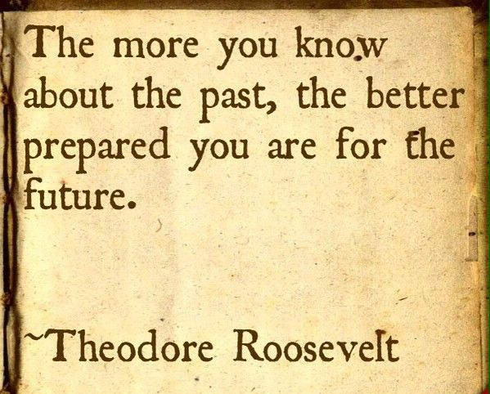

The Priory Parish CE Primary School

History Policy



**Statement of Intent**

At The Priory Parish CE Primary School, we believe that, through the study of history, children make sense of their world and enrich their understanding of it. This policy sets out the framework in which the history curriculum will be taught. Through this curriculum children will understand the similarities and differences between societies and cultures, and the impact of changes on people and place.

**Legal Framework**

This policy has due regard to statutory guidance including, but not limited to, the following:

DfE (2014) ‘National Curriculum in England: History Programmes of Study’

DfE (2017) ‘Statutory Framework for the Early Years Foundation Stage’

**Through the framework of the National Curriculum 2014, history aims to ensure that all pupils:**

* Know and understand the history of these islands as a coherent, chronological narrative, from the earliest times to the present day: how people’s lives have shaped this nation and how Britain has influenced and has been influenced by the wider world.
* Know and understand significant aspects of the history of the wider world: the nature of ancient civilisations; the expansions and dissolution of empires; characteristic features of past non-European societies; achievements and follies of mankind.
* Gain and deploy a historically grounded understanding of abstract terms such as ‘empire’, ‘civilisation’, ‘parliament’ and ‘peasantry’.

* Understand historical concepts such as continuity and change, cause and consequence, similarity, difference and significance, and use them to make connections, draw contrasts, analyse trends, frame historically-valid questions and create their own structured accounts, including written narratives and analyses.
* Understand the methods of historical enquiry, including how evidence is used rigorously to make historical claims, and discern how and why contrasting arguments and interpretations of the past have been constructed.
* Gain historical perspective by placing their growing knowledge into different contexts, understanding the connections between local, regional, national and international history; between cultural, economic, military, political, religious and social history; and between short and long-term timescales.



Early Years Provision:

 There are seven areas of learning and development that must shape educational programmes in early years settings. All areas of learning and development are important and inter-connected. Three areas are particularly crucial for igniting children’s curiosity and enthusiasm for learning, and for building their capacity to learn, form relationships and thrive. The most relevant early years outcomes for history are taken from the following areas of learning:

Understanding the World

People and communities: children talk about past and present events in their own lives and in the lives of family members. They know that other children don’t always enjoy the same things, and are sensitive to this. They know about similarities and differences between themselves and others, and among families, communities and traditions.

The world: children know about similarities and differences in relation to places, objects, materials and living things. They talk about the features of their own immediate environment and how environments might vary from one another. They make observations of animals and plants and explain why some things occur, and talk about changes

Key stage 1 :

Pupils should be taught about :

* Changes within living memory and changes within national life.
* Events beyond living memory that are nationally and globally significant.
* The lives of significant individuals in the past who have contributed to national and international achievements.
* Significant historical events, people and places in their own locality.

Key stage 2 :

Pupils should be taught about :

* Changes in Britain; Stone Age to the Iron Age, the Roman Empire, the Anglo-Saxons and Scots, the Vikings to the time of Edward the Confessor.
* Ancient Greece - a study of Greek life, achievements and their influence on the western world.
* The achievements of the earliest civilisations.
* A local history study.
* A study of an aspect or theme in British history that extends pupils chronological knowledge beyond 1066.
* A non-European society that provides contrast with British history - chosen from : early Islamic civilisation, including a study of Baghdad c.AD 900, Mayan civilisation c.AD 900, Benin, West Africa c. AD 900-1300.

**Roles and Responsibilities :**

History Subject Lead :

* Undertake monitoring in the standards of history.
* Provide leadership and management of history to secure high quality teaching and learning,
* Play a key role in motivating, supporting and modelling good practice for all staff.
* Take a lead in policy development and review.



* Keeping up to date with current affairs and best practices regarding history.
* Attending subject specific courses in order to provide guidance to staff as part of their own professional development.
* Reporting to SLT on history related issues.
* Plan and organise the allocated purchase of resources in accordance with the available budget.
* Celebrate and promote the history curriculum and pupils work throughout the school.

Teaching Staff :

* Develop schemes of work and lesson plans in line with the school’s history policy and objectives of the national curriculum.
* Facilitate the teaching of their history curriculum.
* Assess and record pupils progress within the history curriculum.
* Keep appraised on current affairs and best practice on their history curriculum and applying this to their schemes of work.

**Teaching :**

The history subject lead is responsible for overseeing the planning, resourcing and monitoring of the school’s history programme.

The subject matter covered in history reflects the requirements of the 2014 National Curriculum.

Special focus will be paid to the teaching of the skills inherent in the entire history curriculum taught at The Priory Parish CE Primary School. These skills include :

* Making accurate observations.
* Asking and answering questions.
* Effectively using the appropriate equipment for measurement.
* Recognising patterns and identifying relationships.
* Predicting and applying knowledge to different contexts.





* Analysing and interpreting evidence and drawing conclusions.

The history programme will be delivered by all staff in a range of teaching and learning situations with respect to the needs of individual pupils.

**Differentiation :**

At the Priory Parish CE Primary School we recognise the fact that in all history classes there are children of a variety of abilities, and we seek to provide suitable learning opportunities for all pupils by matching the challenge of the task to the ability of the child.

**Inclusion :**

At the Priory Parish CE Primary School we value each person as a unique individual. We strive to meet the needs of all our children, adults and all members of the school community. All children should have access to a broad, balanced curriculum and make progress at their own pace. Specific children with special needs ranging from SEN and G&T and EAL have differentiated work that takes account of the targets set for children in their Individual Education Plans.

**Assessment :**

The history subject lead will ensure that assessment :

* Is embedded as an essential part of teaching and learning.
* Involves sharing learning objectives and success criteria with pupils.
* Aims to help pupils to know and recognise the standards they are aiming.
* Involves pupils in peer and self assessment.
* Provides subject specific feedback which leads pupils to recognising their next steps and how to take them.
* Involves both teachers and pupils reviewing and reflecting on assessment data.

**Continuity and Progression :**

The long and medium term plans based on National Curriculum show coverage and the progression of skills are plotted throughout the school. It is the coordinators role to monitor continuity and progression.

**Equal Opportunities :**

It is important when teaching history that we encourage certain values and attitudes. Through understanding and knowledge comes respect. Through the study of different places/people/events, we aim to develop children’s understanding and knowledge of peoples’ race, religion and culture. Historical learning will offer equal interests and opportunities to both boys and girls and prepare them adequately for adult membership of a multi ethnic and multicultural society.

Signed : _________________________________ Date : __________________________

Chair of Governors

Signed : _________________________________ Date : __________________________

Headteacher

Date to be reviewed : ____________________

