How is reading taught at our school?
A combination of high quality resources and teaching ensure all NC skills are covered whilst instilling a love of reading.
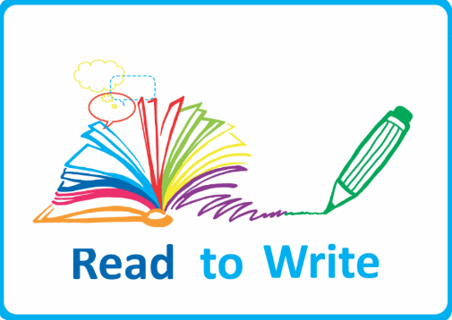 | We use Read to Write as the basis for our English planning from F2 (alongside RWI) to Y6. Read to Write empowers teachers to provide high-quality teaching of reading and writing through high-quality literature. These detailed units of work centre on engaging, vocabulary-rich texts, with a wealth of writing and reading opportunities within and across the curriculum. All English NC objectives are covered for each year group within the 6 units of work.
We identify that historically, (despite countless courses, meetings, letters etc) our children don’t often read at home with an adult. We decided that we needed to plug this gap in school time. Accelerated Reader is a powerful tool we use for monitoring and managing independent reading practice, while promoting reading for pleasure.
Children read in school for at least 20 minutes every single day and take quizzes to test and develop their comprehension skills. They receive points for the books they read and the accuracy of their quizzing- points=prizes and treats! This has had a huge impact on our reading culture as a school and we are delighted with the progress our pupils have made so far.
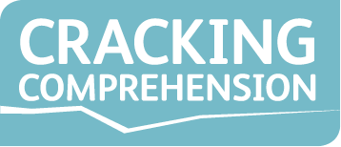 | We use Cracking Comprehension in years 2-6. With a mix of interactive whiteboard activities, practice texts and assessment tasks, Cracking Comprehension allows our teachers to model, and children to practise the skills and techniques needed to improve reading comprehension skills.
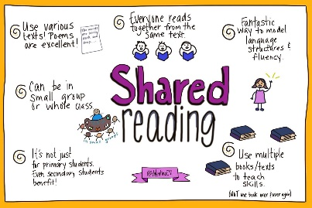 | During snack time/ story time we adopt the ‘shared reading’ approach. This is a crucial time in which teachers model expression and intonation. We ask carefully thought out questions which engage the children and continue to develop their comprehension skills. This is also a time of enjoyment and books are carefully and thoughtfully selected.
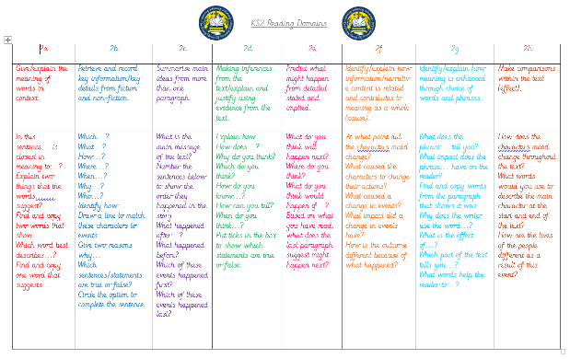 | 1:1 reading time with an adult is another chance for pupils to develop both their fluency and comprehension skills. Children are asked questions based on their focus content domain and their answers are recorded to show progression/ next steps. This is also a valuable time in which children can enjoy reading with an adult and have reading elements such as expression modelled to them if appropriate,
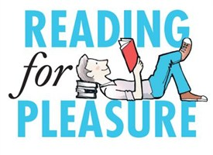 | Reading for pleasure is crucial at our school as it is a time when children can apply all of their hard work and just read for purely relaxation and enjoyment! We recognise the importance of this in harnessing a lifelong love of reading. Children have many opportunities on a daily basis to just read for pleasure.
 | RWI phonics is used in Early Years Foundation Stage to teach early reading skills. RWI 1:1 is also used for pupils who need intervention and catch up sessions.

