Curriculum Policy

The Priory Parish CE Primary School

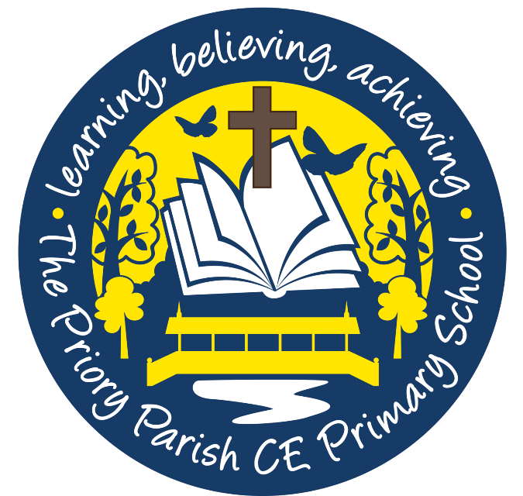

**Updated May 2020**

‘Start children off on the way they should go,  
    and even when they are old they will not turn from it.’

Proverbs 22.6

Our Vision

*‘As a Christian family, together, we will realise our God-given ability to change the world.’*

Based on the story of the Good Samaritan

Luke 25-37

Our Curriculum Rationale

Our curriculum is designed to give all of our children the very best opportunities to make our vision a reality. We have built it around the acronym R-A-I-S-E.

Retention of powerful knowledge and vocabulary

Application

Inspiration

Success

Elevate

At The Priory we believe every child can:



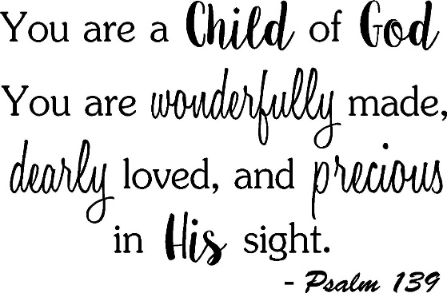

Foreword

We have carefully tailor designed our own curriculum to ensure our children experience purposeful, exciting and inspirational learning opportunities. This will broaden their horizons and enrich their knowledge as required in the National Curriculum and beyond. We want our children to experience all of the joy and powerful knowledge a well thought- out and imaginative curriculum can provide. We are extremely passionate about achieving this. We have been brave and bold in the opportunities we have planned for our pupils as we want our curriculum to be exciting, challenging and adventurous!

When designing our curriculum, we held many things at the forefront of our minds including:

* Our vision and Christian values which we hold dear;
* The crucial knowledge we want our pupils to know, understand and apply;
* Providing our pupils with exciting, inspirational and adventurous experiences;
* Promoting the moral, social and spiritual development of our children;
* Planning for the careful progression of knowledge year upon year to master and deepen;
* Providing a relevant and meaningful curriculum for our children, which they can relate to, and feel pride towards;
* Creating a curriculum that breaks boundaries and takes our children to unknown destinations and experiences!
* Providing every child with a curriculum which is fun and enjoyable;
* And above all else, creating a curriculum which provides them with the determination, passion and dedication to succeed in their future lives.

Introduction

At The Priory Parish CE Primary School, Christian values and high expectations are at the heart of all aspects of our school life, providing a safe, happy and caring learning environment. Our children are encouraged to develop independence, self-esteem and confidence whilst reaching their full potential. We aim to find exciting ways to enable children to learn, developing creativity and imagination along the way with a strong sense of belonging.

At The Priory, we celebrate success and encourage everyone to achieve their full potential by working together in partnership with parents, carers, the Church, Governors and wider community.

Our school's curriculum is all the planned activities that we organise in order to promote the learning of knowledge, personal growth and development. It includes not only the formal requirements of the National Curriculum, but also other aspects of study that we feel are particularly relevant to our children and community.

We strive to provide a curriculum which inspires, stimulates creativity and is relatable to our pupils and their local area. Additionally, we seek to achieve further enrichment through a range of extra-curricular activities and clubs, trips, wow days, visitors and experiences. We have a passion for enriching the lives of our pupils and giving them opportunities and experiences which they may not otherwise get outside of school. Our provision also includes our own Church ethos in which we aim to develop the whole child. We want children to grow into positive, responsible young people, who can work and cooperate with others, whilst at the same time developing their knowledge and skills, in order to achieve their true potential. We want them to understand the importance of their place in the community and wider world and be confident advocates for change.

At The Priory, we seek the highest standards of attainment for all our children, understanding the vital need for an inclusive education. We aim to foster creativity in our children, and to help them become independent, successful learners. Above all, we believe in making learning both purposeful and fun. We aim to ensure that pupils progress at each transition point with the skills they need to ensure success in their future. Staff work closely with each other to ensure smooth and successful transitions through foundation stage, year groups, key stages and on to secondary school where we liaise with colleagues in our local secondary schools regarding the transition of our Year 6 pupils.

We are a church school and a caring school family. Our vision and Christian values are at the heart of our teaching and learning. We want our children to grow up and have a sense of appreciation for the world in which we live; feeling a valuable part of it, knowing they have a contribution to make. We recognise and respect the range of beliefs and cultures within our world and promote diversity through a thoughtful curriculum and engaging workshops with both children and parents and trips. We are also on our journey to becoming a ‘School of Sanctuary’.

Our vision and values at The Priory Parish

Our school curriculum is underpinned by our school vision and Christian values that we hold dear, alongside the fundamental British values in which we underpin all we do. The curriculum is the means by which the school achieves its objective of educating children in the knowledge, skills and understanding that they need in order to lead fulfilling lives.

We also designed our curriculum based on the interests, needs and passions of our pupils. We want them to drive their own curriculum to ensure we capture, inspire and nurture their interests. The main values of our school, upon which we base all that we do are: love, faithfulness, responsibility, kindness, friendship and respect. Our vision and values guide all that we do and are woven throughout our curriculum and in daily school life at The Priory.

Aims of our school curriculum

The aims of our school curriculum are:

* To enable all children to learn and retain the powerful knowledge they need to succeed;
* To refine and develop their skills, to the best of their ability;
* To promote a positive attitude towards learning, so that children enjoy coming to school, and acquire a solid basis for lifelong learning;
* To teach children the life skills of English, Maths, science and computing;
* To provide our children with exciting experiences and adventures which capture their interests and ignite sparks in their minds;
* To enable children to be creative and to develop their own thinking;
* To teach children about the developing world, including how their environment and society have changed over time; and how they can make positive changes to our community and world.
* To teach our children to be brave, advocacies of change. We want our children to know and believe that one voice can change the world for the better.
* To help children understand Britain's cultural heritage and the history of the area we live in;
* To appreciate and value the contribution made by all ethnic groups in our multi-cultural society;
* To enable children to be positive citizens;
* To fulfil all the requirements of the National Curriculum and the Diocesan Syllabus for Religious Education;
* To teach children to have an awareness of their own spiritual development, and to distinguish right from wrong;
* To help children understand the importance of truth and fairness, so that they grow up committed to equal opportunities for all;
* To enable children to have respect for themselves and high self-esteem, and to live and work cooperatively with others.
* To believe in themselves and know that through care and hard work they can achieve their dreams.
* Most importantly we want our children to know that we love and care for them and believe that they can be the best version of themselves. This will underpin all aims of our curriculum.

Planning

Our curriculum was carefully planned and tailor made with our vision and children at the forefront.

* Each subject has a ‘curriculum design’ which was thoughtfully and carefully put together by us as school. This also reflects the requirements of the National Curriculum.
* The curriculum design for each subject is followed by each class.
* We use our Priory progression maps which we have created for each subject when planning to ensure skills progress year on year across our subjects.
* We display our ‘Big question’ for each topic and make links between subjects to ensure fluidity which increases depth of knowledge.
* Weekly planning sheets which include lesson, National Curriculum/EYFS objective and activity for each lesson is uploaded onto the shared drive each week.
* Important health and safety information is annotated onto plans.

Knowledge Organisers

* For every topic in every foundation subject, we create knowledge organisers.
* Our knowledge organisers contain all of the essential knowledge we want our children to know and retain by the end of the topic.
* Our knowledge organisers guide us in our planning, are stuck in books for children to access and are sent home to parents at the beginning of each topic.

A knowledge organiser includes:

* Key knowledge needed in the topic.
* Key vocabulary with definitions.
* Relevant illustration /map/diagram/timeline.
* Additional learning section.
* Learning at home section.
* A small ‘relevant to me’ box- E.g- Where do I live?
* History- timeline of key events to develop chronology.
* Geography- A relevant map/ diagram to build understanding of topic.

Quizzing

We use quizzing as an assessment tool to test if knowledge has been retained and has become ‘sticky’.

Quizzes created are:

* A reflection of learning and knowledge taught.
* A tool for assessing progress from the start- end of a topic.
* A tool for building retention of knowledge.
* Up to 10 questions (one question per lesson objective).
* Can be multiple choice, open ended or explanation questions.
* Questions will be revisited during fab facts/ later quizzes to build retention of knowledge.
* Quizzes will be stuck in books at the beginning of a unit (after the knowledge organiser).
* At the start, pupils will answer the questions independently to assess any prior knowledge. They will then complete the same quiz at the end of the unit to assess progress of knowledge.

Mindmapping

We use mindmapping at the start of each topic and add to it as knowledge grows.This systematic way of organising knowledge into ‘branches’ helps children to organise, catogerise and process new knowledge leading to greater retention. It is also a really useful tool for showing progression in knowledge from the beginning- end of a topic.

Foundation Stage

The curriculum that we teach in our F1 and F2 classes meet the requirements set out in the statutory framework for EYFS. Our school fully supports the principle that young children learn through play, and by engaging in well planned and structured activities. Teaching in the F2 class builds on F1’s experiences of the children due to the close relationship our F1 and F2 classes have.

Using Target Tracker, staff will evidence and assess the skills and development of each child against each child’s age and stage, enabling them to make judgements of learning. The Foundation Stage leader Mrs Lunn, meets regularly with staff in both F1 and F2 to ensure consistency and offer planning advice. When staff are planning, they take into account the characteristics of learning for each child. Once again, topics are carefully and thoughtfully chosen to reflect the needs and interests of our children, enabling them to access new experiences.

Individual Subjects- see subject policies for indepth information.

English

* Quality recommended texts are used to enhance and support learning of National Curriculum objectives. We use the ‘Literacy Counts: Read to Write’ approach which focuses on the use of quality texts to promote reading and writing skills.
* Babcock must be used in years 2-6 to support the teaching of spelling. Y1 follow the RWI phonics programme alongside Literacy Counts.
* Accelerated Reader- children will read 5 times a week for at least 20 minutes. They will take online quizzes to assess their understanding of the texts they read. Children’s ability and progress will be assessed each half term using the ‘Star Reader’ assessment tool.
* Big Write is once every two weeks (on a Friday). Children use purple pens to edit and evaluate their work based on feedback from previous big write. Big Write is marked ‘in-depth’ (See assessment policy). Children are given ‘travelling targets’ in their books.
* Vocabulary development is a priority to ensure our children have a rich and varied vocabulary that they understand. We have an adventurous vocabulary policy to ensure pupils are exposed to exciting and rich vocabulary.
* Reading is also assessed using NTS Reading tests.

Maths

* Maths No Problem is used for planning across years 1-6
* Foundation stage use Maths No Problem style reasoning, looking at individual numbers.
* Times Tables must also be taught and tested as extra sessions to ensure consolidation and that expectation is at National Curriculum standards. Times table Rockstars will be used to support this.
* Maths is assessed using NTS Mathematics tests.

Science

* Use of Collins Connect Primary Planning.
* Science is assessed using NTS Science after each unit.

PE

* Twice weekly PE sessions to improve health and fitness.
* Teaching about the importance of a healthy lifestyle must also be included in other aspects of our weekly planning to ensure full coverage of this area.
* Swimming lessons for KS2 (children will repeat lessons where necessary to ensure ‘every child is a swimmer’ by the time they leave The Priory.
* P.E Passport is used as a planning and assessment tool to support the teaching of P.E.
* Competitions are important. We participate in these frequently with our local cluster.

Computing

* Carefully planned to enhance and support our curriculum and learning in other subjects.
* Ensuring children have key skills in computing.
* E-Safety is a high priority and staying safe online.
* Hi Impact workshops are used with every class throughout the year to help teachers develop their skills and expertise in offering our children a rich and exciting computing curriculum.

History and Geography

* Both tailor made to provide our pupils with relevant, exciting and meaningful knowledge and learning opportunities.
* We have created progression maps for both subjects which carefully break down the knowledge and skills needed in each year group. This has led to much more focused, careful planning and enables children to build on their skills year on year.
* Topics meet the requirements of the National Curriculm as do all of our subjects. We make fluid links between other subjects to increase the depth of powerful knowledge and understanding.
* Assessed using quizzing.

RE

* Chester Anglican scheme of work focused on key concepts in the Bible and other faiths.
* Links made across the whole curriculum including collective worship.
* Assessed using end of unit assessment sheets.

Art/DT

* Both tailor made to provide our pupils with relevant, exciting and meaningful knowledge and learning opportunities.
* A range of 2D and 3D art work.
* Studies of famous artists and designers.
* Development of cooking, building and sewing skills.
* Carefully linked to other areas of the curriculum e.g history.
* Adventurous and exciting development of creativity and skills.
* Progression maps to show knowledge and skills development.

PSHE

* Heartsmart resource
* Understanding the importance of developing children spiritually, morally and socially.
* Embedded across all subjects.
* Healthy Eating and mental wellbeing focus.
* Safeguarding is a priority.

Music

* Tailor made to provide our pupils with relevant, exciting and meaningful knowledge and learning opportunities.
* Class workshops once a term to develop skills.
* Use of music to enrich topics.
* We have created a music progression map.
* Enrichment opportunities including: performances, musical theatre club, choir, philharmonic trips.
* Links to enriching cultural capital in our pupils: listening to a range of music types.

Languages

* Spanish lessons once a week with Mr Whalley in KS2.

Collective Worship

Collective worship is strategically planned to enhance many aspects of learning including the following:

* Links to support and enhance our school development plan
* Links to understanding core British values
* Links to RE and worship which reflect the Christian ethos of our school
* Celebrating special events, other faiths and cultures.
* Promotion of mental health and wellbeing

Whole School Events which enhance our curriculum

* Many events are planned for each year which enhance and impact learning and the curriculum. Examples of events which take place are:
* Sports Day
* Health week
* Safety week
* E-safety week
* Community projects such as ‘Birkenhead Blue Heart’.
* Fitness Fortnight.
* Charity fundraisers including: Red Nose Day, Children in Need, Sports Relief, special Church events.
* Supporting the environment- litter picks, beach clean ups.
* Trips
* Community support and visits.
* Competitions
* Quizzes with local schools.
* CPAS ventures

Class Trips

* Every class will go on trips throughout the year to support and enhance learning in different areas. We expect at least one trip per half-term.
* Y5 take part in the annual CPAS Venture alongside other local Church schools.
* Y6 visit Oaklands for a residential trip annually.

Extra-Curricular Activities

We are committed to developing the whole child. We extend the curriculum by offering extra-curricular activities, including: Football, Instruments, Art Club, Eco Club, dance, choir and many more.

The Inclusive Curriculum

Our school provides high quality provision to meet the needs of all children and young people with SEND. Differentiated and personalised learning is always available for our pupils. We adhere to the statutory SEND Code of Practice (2014). Our SENCO is also our Language Base Teacher and offers support to both pupils and staff in ensuring children are provided with the upmost care, high quality provision and support.

Intervention

We have numerous intervention groups to ensure children are fully supported with their learning needs. Intervention groups run all the way from Foundation Stage to Year 6.

Interventions include:

* Daily Maths No Problem catch ups
* Writing intervention
* Phonic support groups
* Booster groups
* Time to Talk
* Socially Speaking
* Handwriting group
* Spelling focus groups
* Times table intervention

We are very cautious when providing intervention that this does not affect a child’s ability to access the whole curriculum. We thoughtfully swap timetables around and choose timings wisely to provide every child with a full and balanced curriculum whether they need intervention or not. We do not want any child to miss out on the exciting experiences our curriculum has to offer.

Parental Involvement

We highly value parents and work in partnership with them to enrich the curriculum. Parents are informed about the curriculum through knowledge organsiers, half termly newsletters, homework, parent meetings and curriculum workshops. We positively encourage them to become involved with school and their child’s learning. We are well aware that all children need the support of both the parents/carers and the teachers to make good progress in school. We strive to build positive links with the parents/carers of each child, by keeping them informed about how the children are being taught, and how well each child is progressing.

Subject Leaders

The role of the subject leader is to:

* *Provide a strategic lead and direction for the provision and development of their subject;*
* *Support and advise colleagues on issues related to the subject;*
* *Monitor pupils' progress in that subject area;*
* *Provide efficient resource management for the subject.*
* *Subject leaders monitor the way in which their subject is taught throughout the school.*

It is the role of each subject leader to keep up to date with developments in their subject, at both national and local levels. They review the way in which the subject is taught in the school, and plan for improvement. This development planning links to whole-school objectives.

List of Subject Leaders

|  |  |
| --- | --- |
| SENCO | Jo Morris |
| English | Sophie Ellison |
| Maths | Lisa Baker |
| Science | Mike Studley |
| Computing | Greg Edwards |
| PE | Alison Booth |
| History | Clare Robertson |
| Geography | Laura Williams |
| Art and DT | Natalie Farrell |
| Music | Lisa Baker |
| RE | Sophie Ellison |
| PSHE | Sophie Ellison |
| MFL | Lisa Baker |

At The Priory, we consistently evaluate and review our whole school curriculum and are constantly developing new ways and ideas to ensure learning is enjoyable, purposeful and successful in ensuring our pupils achieve the best they possibly can.

