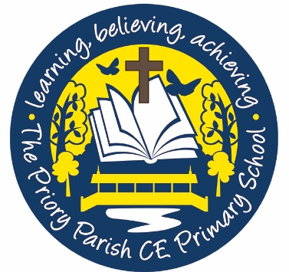

Cookie Policy

We ask that you read this cookie policy carefully as it contains important information on and our use of cookies on our website.
What are cookies?
Cookies are small data files that are placed on your computer or mobile device when you visit a website. Cookies are widely used by online service providers to help build a profile of users. Some of this data will be aggregated or statistical, which means that we will not be able to identify you individually.
You can set your browser not to accept cookies and the websites below explain how to remove cookies from your browser. However, some of our website features may not function as a result.
How we use your cookies
The Priory Parish C of E Primary School may request cookies to be set on your computer or device. Cookies are used to let us know when you visit our website, how you interact with us and to make your experience using the school website better for you. The cookies we collect will differ depending on what you are looking at on our website. You are able to adapt your cookie preferences, but by blocking certain types of cookie it may mean that your experience on the website is impacted.

Types of cookies we use are:
The cookies we place on your device fall into the following categories:
- Session cookies—these allow our website to link your actions during a particular browser session. These expire each time you close your browser and do not remain on your device afterwards
- Persistent cookies—these are stored on your device in between browser sessions. These allow your preferences or actions across our website to be remembered. These will remain on your device until they expire, or you delete them from your cache
- Strictly necessary cookies—these cookies are essential for you to be able to navigate our website and use its features. Without these cookies, the services you have asked for could not be provided
- Performance cookies—these cookies collect information about how you use our website, eg which pages you go to most often. These cookies do not collect personally identifiable information about you. All information collected by these cookies is aggregated and anonymous, and is only used to improve how our website works

Consent to use cookies
We will ask for your permission (consent) to place cookies or other similar technologies on your device, except where these are essential for us to provide you with a service that you have requested (eg to enable you to put items in your shopping basket and use our check-out process).
There is a notice on our home page which describes how we use cookies and requests your consent to place cookies on your device.

How to turn off cookies
If you do not want to accept cookies, you can change your browser settings so that cookies are not accepted. If you do this, please be aware that you may lose some of the functionality of this website. For further information about cookies and how to disable them please go to the Information Commissioner’s webpage on cookies: https://ico.org.uk/for-the-public/online/cookies/.

How to contact us
Please contact us, if you have any questions about this cookie policy.
If you wish to contact us, please send an email to [schoooffice@thepriory.wirral.sch.uk], or write to The Priory Parish C of E Primary School, Aberdeen Street, Birkenhead, Wirral, CH41 4HS] or call [0151 647 7188].

Changes to this policy
This policy was published on June 2021 and will be updated in June 2022.

