Autumn 2 - 2016 Newsletter
The Priory Parish CE Primary School

‘For God so loved the world that he gave his one and only Son, that whoever believes in him shall not perish but have eternal life.’
John 3:16

Events Spring term
January 5th and 6th
School is closed. Staff development day.
Monday 9th January
Children return to school
Thursday 19th January
KS1 Film Club – to raise money for our friends in Uganda
Friday 17th February
Break up for half term
Monday 27th February
School reopens

Dear Parents
Christmas is once again upon us and what a busy term we have had. Can I extend a big thank you to all the children and staff who combined so brilliantly to produce two great nativities. I hope you had the chance to see them. What always amazes me is how the children respond to performing, particularly when they know their families are watching. This support gives them great encouragement and I know you will continue to give this to all aspects of school life.
Our Christmas Fair was a huge success and I felt one of the best we’ve had. Once again can I thank the parents and staff who worked so hard to make it what it was. In addition, thanks to Miss Smith and Mrs Booth for driving such a big undertaking and managing their other teaching duties. Moreover, can I show our gratitude to all those who donated gifts for the fair and raffles.
Bingo was once again well attended and toasty Tuesdays are quickly becoming a Priory institution.
All in all these activities have raised £1580 profit which will go towards supporting the children’s education and enriching our curriculum.
Our school choir has performed on many occasions during the month of December. Over thirty children have shown continued commitment, which alongside a talent for singing, has ensured they have produced fabulous performances for local nursing homes, Birkenhead Park and the evening carol concert at Christ the King. Thank you to Miss Couzens for organising it. I hope the children will continue to enjoy this next year.
At the end of November year 6 went to Oaklands for a week. Despite some very chilly temperatures we had a great time, taking part in gorge walking, rock climbing, zip wiring, hill walking, treks down mines and much more. Furthermore, they were a real credit to the school, showing determination, perseverance, care, respect and team work.
Please read the rest of the newsletter which outlines a very important change to our curriculum next year.
On behalf of all the staff, governors and school community may I wish you a very happy Christmas and safe new year.
Mr Edwards
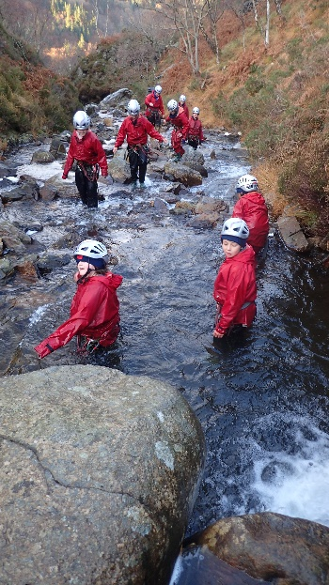
Maths No Problem
In January we will be moving to a new approach to how we teach maths. This is a major change and investment for our school. It is called ‘Maths No Problem’ and derives from Singapore who have led the league tables for standards in maths for many years. A growing number of schools have adopted this approach as we look for the best way to meet the demands of the new curriculum. In a nutshell, it is based upon using apparatus and deep exploration of mathematical concepts. This leads to children being more able and confident to discuss maths and apply their skills to a range of contexts.
Staff are attending two full days of training on 5th and 6th of January so that we are able to start teaching this way on Monday January 9th when the children return.
We will be running workshops on this later in Spring for parents once we become more confident in teaching it. If you would like to find out more about this please follow this link. http://www.mathsnoproblem.co.uk/
Attendance
After a poor first half term our attendance has begun to pick up. As it stands our whole school attendance is 95.9%. This is a big increase from our overall last year of 94.3%. Each day really matters, please, please, please get your child in every day on time. Learning is one of the biggest gifts we can give our children.
F2 –  95.7% | Year 1 – 97.9% | Year 2 – 97.0% | Year 3 – 94.7% | Year 4 – 95.4% | Year 5 – 95.3% | Year 6  94.8%
Our target is over 96%! We can do it!

