The Priory Parish CE Primary School
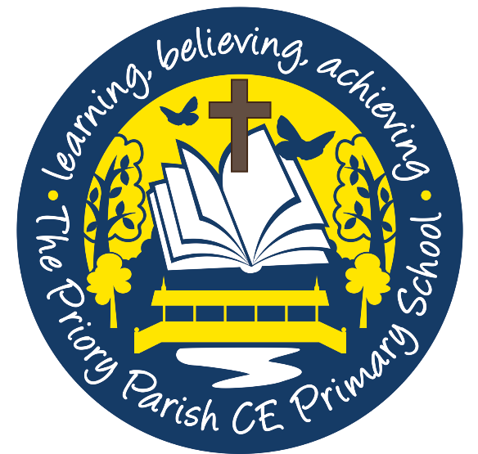

Art and Design Policy 2020

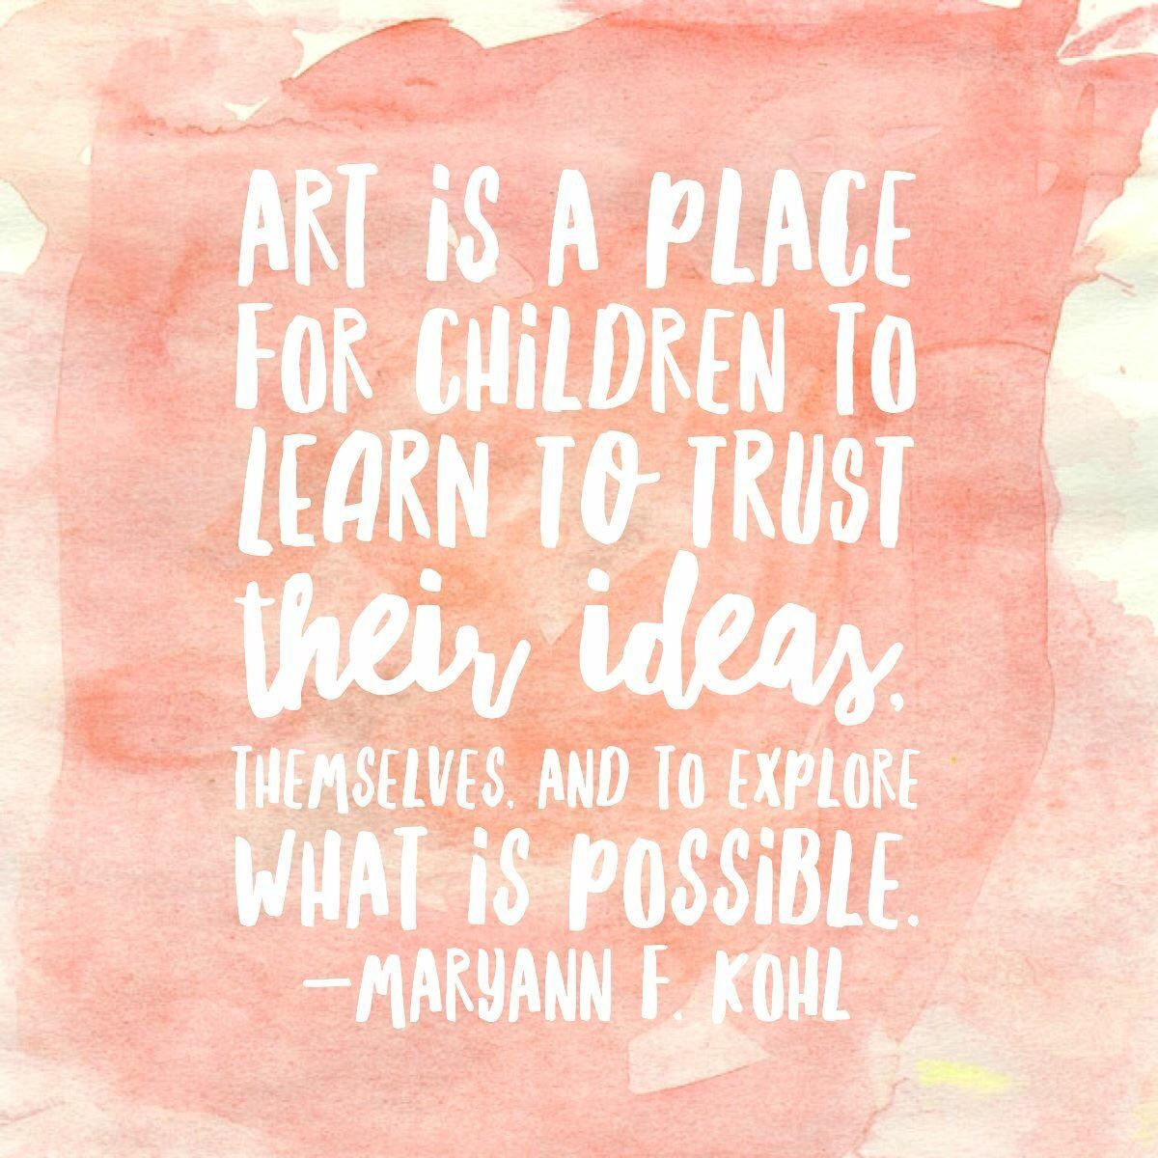

‘As a Christian family, together, we will realise our God- given ability to change the world.’

Our Goals
- To enable every child to develop their natural abilities and potential; to acquire techniques and to practise the skills necessary for creative expression and joyful participation in art and design.

- To provide the support that each child needs to explore and express ideas, feelings and experiences through a range of art activities; building their confidence and self-esteem through valuing artistic self-expression.
We aim to:
- Nurture creativity
- Explore ideas and record experiences
- Inspire and challenge
- Experiment, analyse and evaluate
- Develop key art and design skills
- Teach about amazing artists past and present.

“...he has filled them with the Spirit of God; with wisdom, with understanding, with knowledge and with all kinds of skills; to make artistic designs for work in gold, silver and bronze, to cut and set stones, to work in wood and to engage in all kinds of artistic crafts.”
Exodus 35:31-33

The National Curriculum in England
The national curriculum for art and design aims to ensure that all pupils:
- Produce creative work, exploring their ideas and recording their experiences
- Become proficient in drawing, painting, sculpture and other art, craft and design techniques
- Evaluate and analyse creative works using the language of art, craft and design
- Know about great artists, craft makers and designers, and understand the historical and cultural development of their art forms.

The National Curriculum prescribes that at Key Stage 1 pupils should be taught:
- To use a range of materials creatively to design and make products.
- To use drawing, painting and sculpture to develop their imagination and share their ideas and experiences.
- To develop a wide range of art and design techniques using colour, pattern, texture, line, shape, form and space.
- About the work of a range of artists, craft makers and designers, describing the differences and similarities between different practices and disciplines, and making links to their own work.

The National Curriculum prescribes that at Key Stage 2 pupils should be taught:
- To develop their techniques, including their control and use of material, with creativity, experimentation and an increasing awareness of different kinds of art, craft and design.
- To create sketch books to record their observations and use them to review and revisit ideas.
- To improve their mastery of art and design techniques, including drawing, painting and sculpture, with a range of materials.
- About great artists, architects and designers in history.

Planning and teaching

Early Years Foundation Stage (EYFS)
In the EYFS (Early Years Foundation Stage) pupils are given the opportunity to explore texture, colour, shape, form and space. They develop their imagination and creativity and begin to investigate the qualities of materials and processes. They begin to use colour and shape to express themselves. They investigate the use of pattern and texture to represent ideas and emotions.
In accordance with the EYFS statutory framework (DfE, 2017), art and design is planned and taught through expressive arts and design. Children will:
- Explore and use media and materials: children sing songs, make music and dance, and experiment with ways of changing and representing them.
- Safely use and explore a variety of materials, tools and techniques, experimenting with colour, design, texture, form and function.
- Be imaginative: children use what they have learnt about media and materials in original ways, thinking about uses and purposes.
- Represent their own ideas, thoughts and feelings through design and technology, art, music, dance, role-play and stories.

Key Stage 1 (KS1)
At KS1 pupils develop their skills further through increasing their knowledge and understanding of materials and techniques, environments and their own identity and experiences. At this stage, pupils use colour, shape, pattern and texture to express their emotions and ideas. They begin to ask questions and learn about other artists and art from a variety of cultures. They explore how the art was made, what it was made from and their thoughts and feelings regarding each piece.

Key Stage 2 (KS2)
At KS2 pupils develop their creativity further by increasing their knowledge, skills and understanding of materials and processes. Pupils’ experiences at this stage enable them to begin to understand and unpick the diverse functions of art in the wider world. Pupils learn to improve their use of tools and become confident in using a variety of techniques. Pupils increase their awareness of the purposes of art from historical periods and begin to ask themselves about the purpose, creation, materials and significance of a variety of art works.

The objectives and skills for each key stage are detailed in depth within the subject progression documents and curriculum design documents.

Long-term planning is available to teachers in the form of a curriculum design document created by the art and design subject lead alongside the senior leadership team. This will be used to outline the units to be taught within each year group.
Medium-term planning is produced by class teachers and presented using knowledge organisers. These will be used to outline the vocabulary and skills that will be taught in each unit of work, as well as highlighting the opportunities for assessment through key questions.

Assessment and recording
Assessment and feedback in art and design will predominately be carried out by observation and oral feedback during lessons.
Teachers should ensure that pupils show their progression within each unit in their sketchbook, particularly in KS2. Progression and achievement is tracked against the skills progression documents for the relevant year group. Photographic records and work should be kept in individual sketchbooks.
Assessment can be undertaken in various forms, including:
- Discussing pupils’ work during different stages in the design process to assess understanding
- Close observation of practical tasks and activities
- Pupils’ self-evaluation of their work
- Formative assessment through questioning (including ’Fab Facts’) and end of unit ’quizzes’.

See ‘Sketchbook Standards’ document for more information on recording and presentation expectations in art and design.

Subject Leadership
The subject leader of art and design will:
- Produce the art and design policy and design curriculum maps that meet the statutory requirements laid out by the DfE.
- Produce an annual art and design development plan with realistic and developmental targets.
- Provide advice to teachers or seek information to help support with appropriate resources and approaches to assessment.
- Audit, order and organise the appropriate art resources.
- Attend relevant professional development courses and feedback to staff any new information and ideas.
- Monitor teaching, learning and assessment.

Role of the class teacher
The class teacher is responsible for teaching and developing the curriculum design documents into more detailed schemes of work that ensure that pupils are taught the statutory requirements for art and design.
Class teachers are also responsible for evaluating their schemes of work and for appropriately resourcing the art activities (informing the subject leader should they need specific resources). Class teachers should ensure that the artwork produced by all children is displayed in an appealing way so as to enhance the learning environment and showcase a varied range of artwork. These displays should reflect the unit of work and should have clear descriptions about the theme and who has produced the piece displayed. Displaying the work of the children ensures that they see art and design as a significant subject and allows us as educators to build their confidence and self-esteem within this area of their learning.
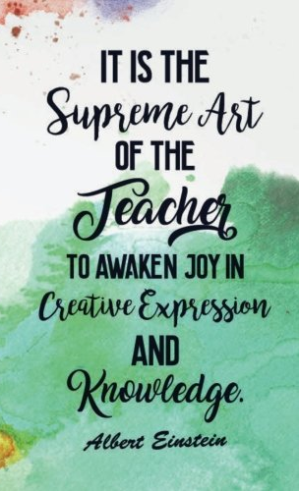

Health and Safety
The teaching staff are responsible for teaching a variety of art and design activities in a safe and secure environment with reference to appropriate risk assessments for activities likely to incur possible risk. The teaching staff are responsible for the supervision of more complex activities such as cutting, printing, batik work and mixing of media. Children are instructed in the correct use of equipment and tools and the specific dangers of using heated or sharp resources are highlighted whenever necessary.
All art equipment is subject to maintenance and safety checks; any faulty equipment is to be removed from the resource area and reported to the subject leader as soon as possible.
Every Child is an Artist
At The Priory Parish, we encourage children to exercise imagination and creativity, appreciate beauty in the world and be alive to experiences of awe and wonder. Art and design allows children to be expressive and creative and it is our expectation that every child will access the art and design curriculum in their own way; through their own interpretations of our teaching. We will provide our pupils with opportunities to express themselves and to utilise their individual skills through art and design.

“In his grace, God has given us different gifts for doing certain things well.”
Romans 12:6
